TMT/Machilipatnam/S0733/2026 02-04-2026

To,

Praveen
Mobile No :+919959050651
City : Machilipatnam.

Dear Sir

SUB :- SUPPLY OF H TYPE HYDRAULIC PRESS

With reference to our discussions regarding your requirement for H type 20ton hydraulic press. We are glad to inform you that, we are in a position to supply you the required equipment. The following are the specifications and our terms and conditions.

S No | Description of the unit | Offer
1. | H type hydraulic press as per photo attached along with 5 hp power pack | Rs 2,40,000/-

Technical Specifications

Pressing Capacity | 20 Tons (200 kN)
Max Working Pressure | 200 Bar – 250 Bar
Cylinder Type | Single acting
Ram Stroke (mm) | 200 mm – 300 mm
Ram Diameter | 80 mm – 100 mm
Table Size (L x W) | 500 mm x 400 mm
Daylight Opening (Max) | 400 mm – 600 mm (distance between ram and table)
Working Height | 850 mm – 1000 mm
Motor Power | 5 HP
Oil Tank Capacity | 20 to 30 liters
Approx. Weight | 700 kg – 1000 kg

Terms and conditions:

- Taxes 18% extra.
- Payment 50% order value as advance, balance before delivery.
- Delivery with in 20 days from the date of your conformed order along with advance.
- Guarantee: one year against any manufacturing defects.

We are sure you will find our offer in line with your requirements. Should you require any clarification please call us to mobile number 98492 07176. Mail id: md@technomachinetools.in

Thanking you and assuring you of our best services

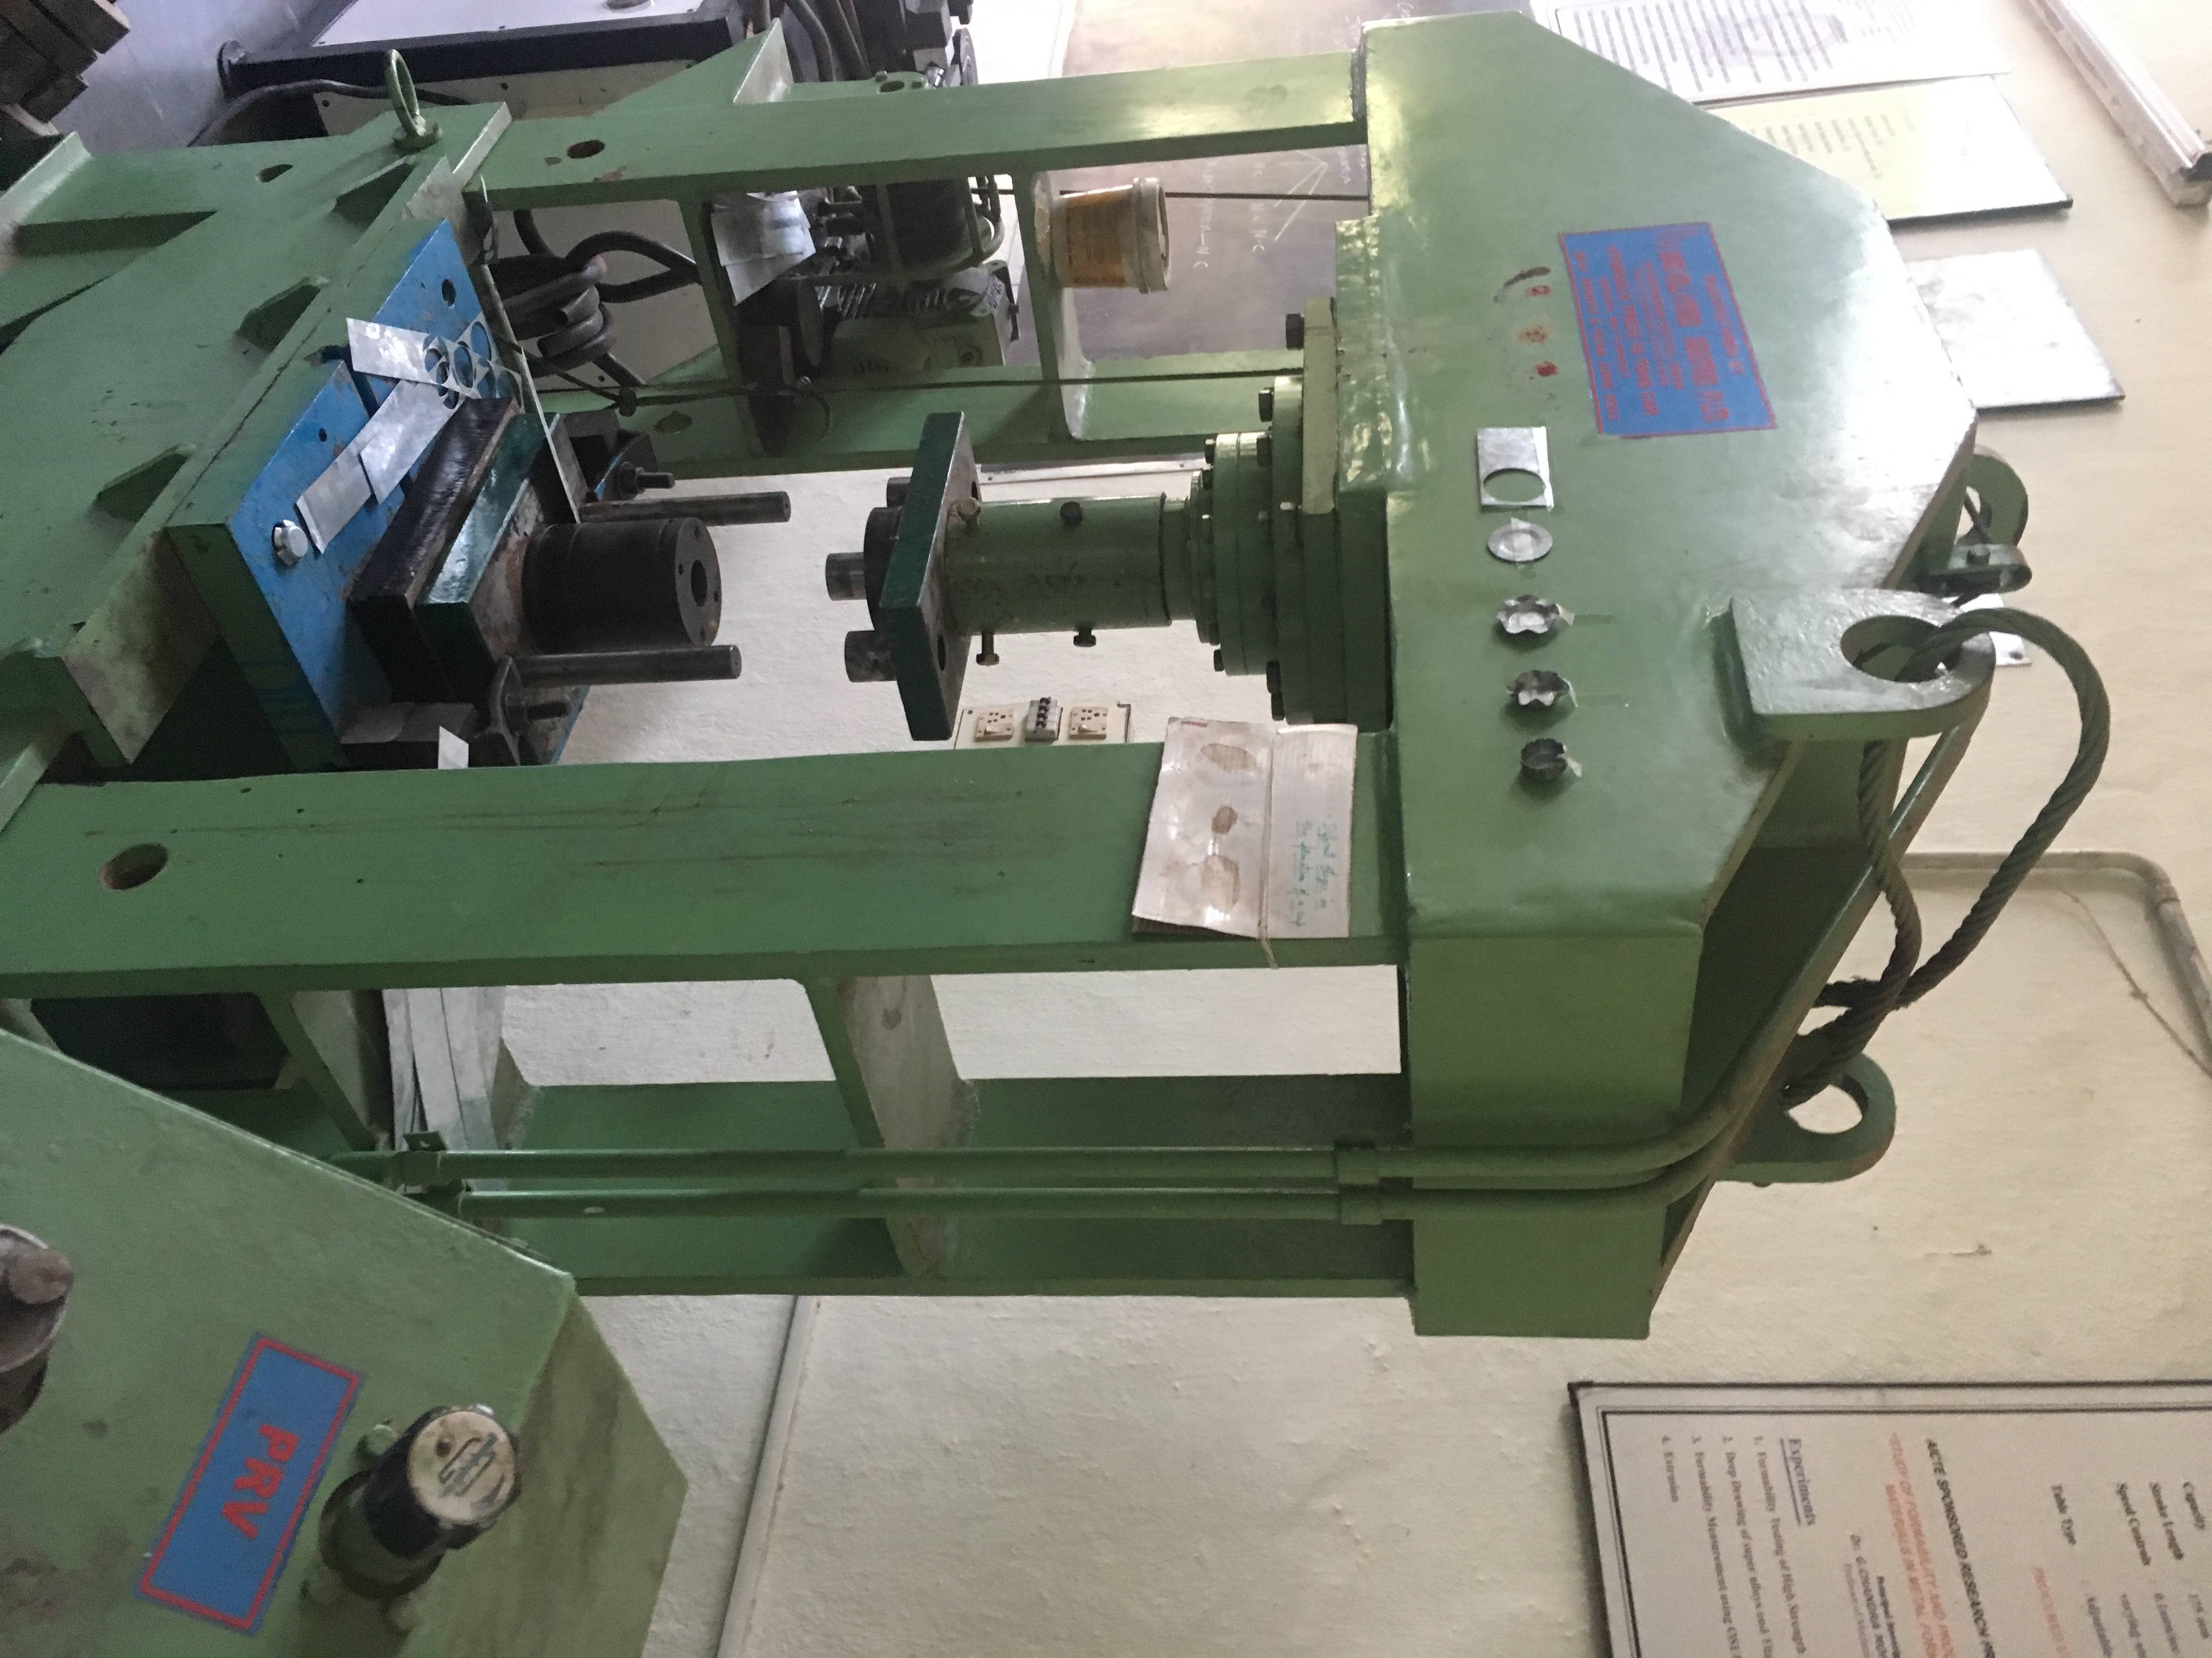

For TECHNO MACHINE TOOLS

( T. SIVARAMAKRISHNA)

TMT/Machilipatnam/S0733/2026 02-04-2026

To,

Praveen
Mobile No :+919959050651
City : Machilipatnam.

Dear sir,

Sub :- Supply of 20 MT C-TYPE HYDRAULIC PRESS.

This is reference to your enquiry for the hydraulic press; we offer our least possible price as under.

C TYPE PRESS :

1) Tonnage : 20 MT.

S No | Description of the unit | Offer/unit
1. | C Type Hydraulic Press with capacity 20 Tons. with Power pack of 5 HP motor and with complete electrical.  Clear pass 250 mm  Hydraulic power pack along with motor 5 hp motor  Tank 100 lts  Yuken vane pump 12 lpm  Pressure gauge 1 No  Level indicator 1 No  Section filter 1 No  Return line filter 1 No  Section strainer 1 no  Manifold block 1 no  Pressure control valve 1 no  Solenoid operated direction control valve 1 no s  Pipes and fittings.  Bell housing 1 no  Pressure gauge 0-250 kg 1 no  Flexible houses 2 no s  Nylon gear coupling 1 no | Rs 2,20,000/-  (Two Lakh Twenty Thousand only)
`
SPECIFICATIONS FOR THE HYDRAULIC PRESS MACHINE WITH 20Ton

1. Tonnage : 20 M.T.

2. Clearance between Housings : 600 mm

3. Daylight : 305 mm

4. Ram stroke. : 400 M.M.

5. Open height. : 530 M.M.

6. Closed height. : 330 M.M.

7. Depth of Throat. : 250 M.M.

- Ram speeds.

a) Approach. : 12 M.M. per Sec.

b) Pressing. : 2 M.M. per Sec.

c) Return. : 20 M.M. per Sec.

9. Motor capacity. : 5 H.P. (Crompton)

10. Bed size. : 600 x 600 M.M.

12. Cost of Machine. : Rs. 2, 20,000/+ Taxes.

13. Mode of payment. : As per the quotation.

14. Delivery. : As per the quotation.

GENERAL TERMS & CONDITIONS:

1 Price quoted per unit ex-work. Hyderabad.
2 Following charges are additional to your account.
- Freight Charge : As actual to be borne by you.
- Sales Tax : 18 % gst.
- Packing charge : As actual to be borne by you.
- Insurance : As actual to be borne by you.
3 Payment : 50% advance along with order another 25%
advance after 3 weeks from first advance and
balance before delivery but after inspection at our
works.
- Delivery : 5-6 weeks from date of techno-commercially clear
purchase order.
- Validity : One month from the date of submission.
- Inspection : Inspection at our works prior to dispatch.
- Warranty : The machine is warranted for a period of 12
months from the date of dispatch against any
manufacturing defects/faulty material or bad
workmanship of any part or component but not
against any kind of abnormal or improper use of
machine. Defective part or component will be
replaced or repaired free of cost. Electrical
components are outside the scope of this
warranty.
- Commissioning : Erection & commissioning done by you, but if
required technical support & guidance provide by
us at additional cost.

NOTE:
- Oil is not in scope of our supply.
- Raw material for trial is arranged by you at your cost.

We are sure you will find our offer in line with your requirements. Should you require any further clarification please call us on mobile number 9246221106.

Thanking you and assuring you of our best services.

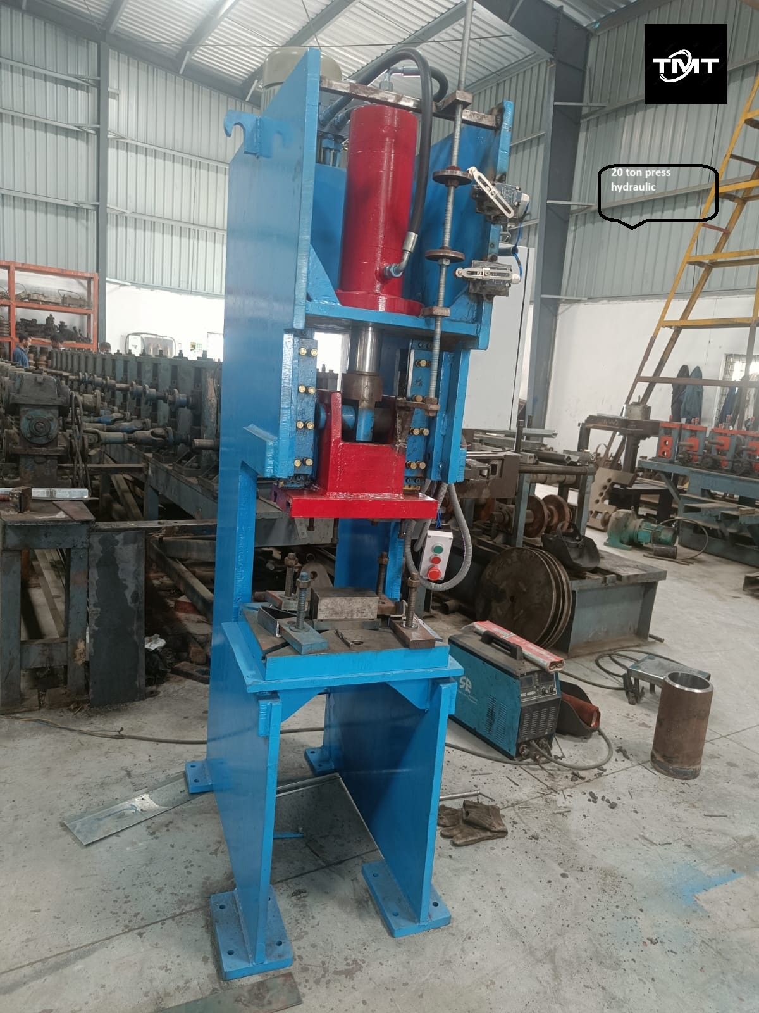

For TECHNO MACHINE TOOLS

T. SIVARAMAKRISHNA

